# Ideation Phase

**Define the Problem Statements**

|  |  |
| --- | --- |
| Date | 10 September 2022 |
| Team ID | PNT2022TMID51589 |
| Project Name | Predicting the energy output of wind turbine based on weather condition |
| Maximum Marks | 2 Marks |

**Problem Statement:**

The prediction of wind power plays an indispensable role in maintaining the stability of the entire power grid. Due to its renewable resources and environmental friendliness, wind speed/power has gained increasing interest worldwide. The wind industry is rapidly expanding into a large-scale industry as a result of the fast-rising amount of installed wind generating capacity worldwide. When it comes to scheduling power systems and other practical aspects of wind energy conversion, such as the dynamic management of wind turbines, reliable short-term wind speed forecasts are essential. A precise forecast is required to solve issues with variable energy production brought on by changing weather patterns. The wind speed has a big impact on how much power is produced by the wind. Despite being quite nonlinear, wind speed exhibits a consistent pattern over a specific amount of time. Thus, wind power forecasting plays a key role in dealing with the challenges of balancing supply and demand in any electricity system, given the uncertainty associated with the wind farm power output.

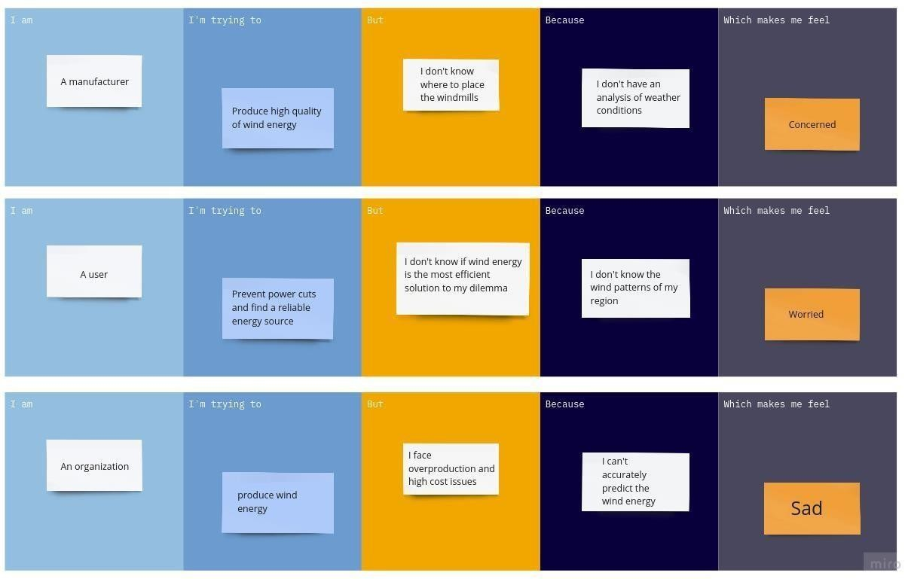

|  |  |  |  |  |  |
| --- | --- | --- | --- | --- | --- |
| **Problem Statement (PS)** | **I am (Customer)** | **I’m trying**  **to** | **But** | **Because** | **Which makes me feel** |
| PS-1 | manufacturer | Produce high quality of wind energy | I don’t know where to place the windmills | I don’t have an analysis of weather conditions | Concerned |
| PS-2 | user | Prevent power cuts and find a reliable energy resource | I don’t know if wind energy is the most efficient solution to my dilemma | I don’t know the wind patterns of my region | Worried |
| PS-3 | organization | Produce wind energy | I face overproduction and high-cost issues | I can’t accurately predict the wind energy | sad |